Activity Tools Using the eTrex GPS
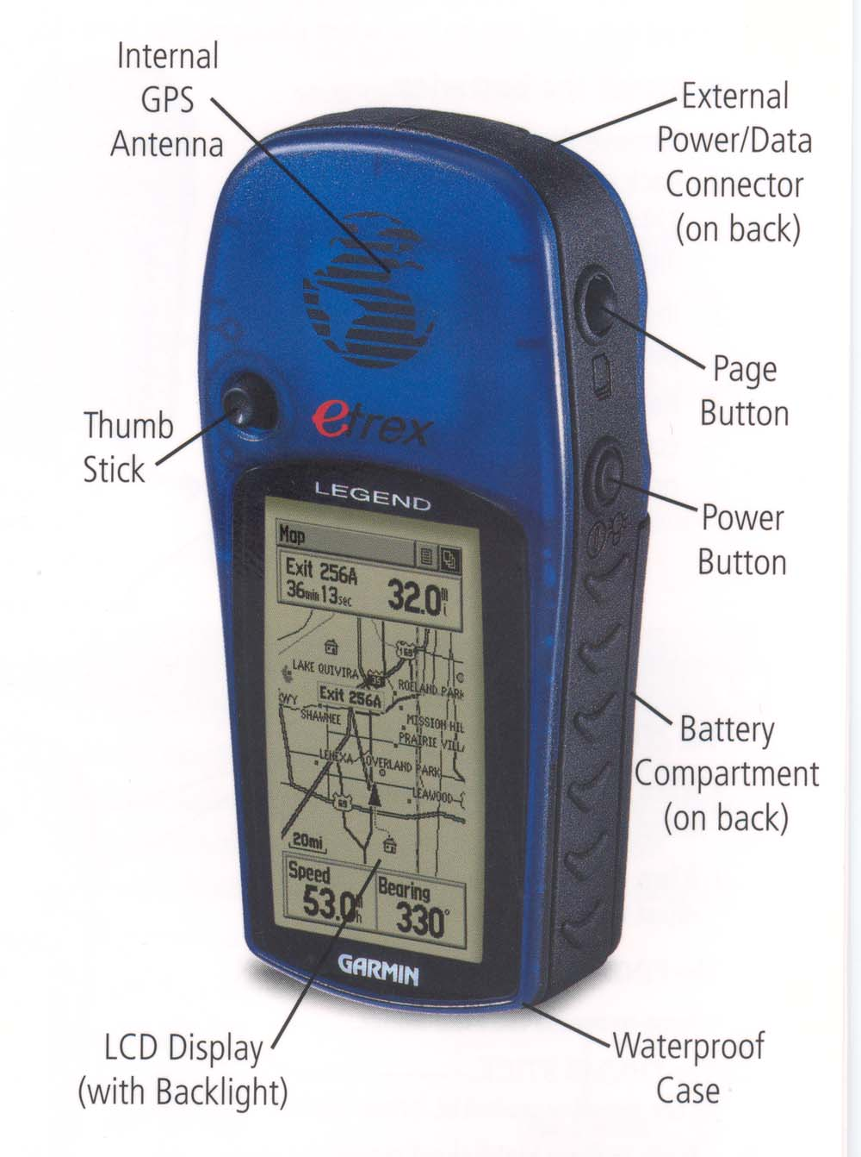

Power on – press the power button firmly and hold for 2 seconds. The screen should show come on and the unit will begin searching for satellite signals.
Once the GPS unit has found satellite signals it will say on the screen, “Ready to navigate: Accuracy X meters.”

PAGE button (top right) – Each time you press the page button you will scroll though the 5 main screens. This button also allows you to go back from menus to the main screen.

The Map Page
Press the PAGE button until you see the map page. The map page shows the network of roads around you, as well as the waypoints you have entered and the tracks you have followed.

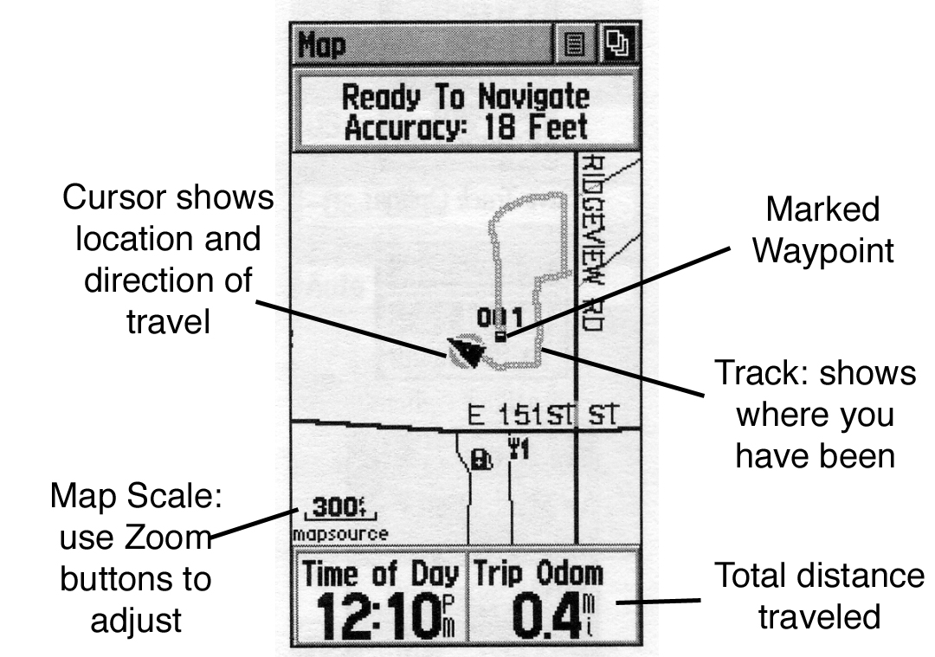
The map page can be used to allow students to track their progress while moving with the GPS unit. They can see where they are in relation to points they have entered. The track will continuously mark itself as the students move with the GPS.

If you cannot see anything except the triangle shaped cursor, or if the map if includes too much area (entire eastern seaboard) then you can adjust the scale of the map by pressing the Zoom buttons and watching the map scale in the lower left hand corner of the display.

The Navigation Page

The Navigation page displays the current direction of travel on the compass ring. It is important to note that the GPS unit IS NOT A COMPASS. The direction of travel can only be determined while you are moving, not by the direction you are facing or holding the unit.
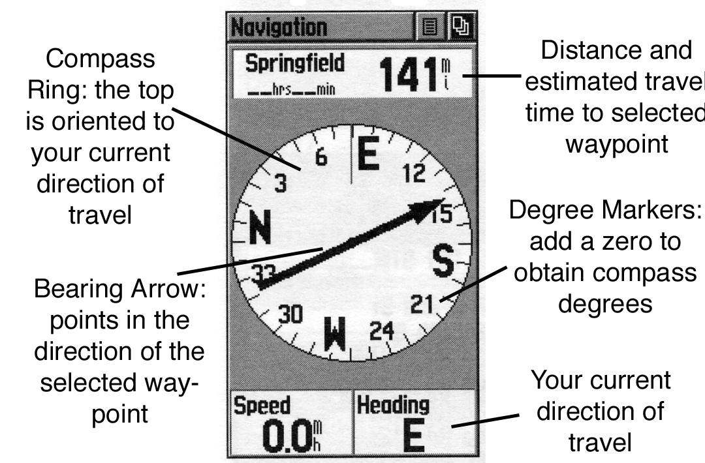

The navigation page can be used to direct you back to a waypoint that you have marked. To do this press the “FIND” button, and then use the click stick to select, “Waypoints,” and then select, “By Name.” This will display a list of all the waypoints you have marked. Select the waypoint you wish to travel to by highlighting and then clicking on it. This will bring you to the page that describes that waypoint, with “GOTO” highlighted. Click “GOTO” and you will come back to the navigation page, with a bearing arrow to show you which way to head to arrive at that waypoint.

The Map and Navigation features of the eTrex GPS can be used to teach about compass directions, mapping skills, geometry, etc. These features can be used in conjunction with a compass and map to illustrate how technology affects the way we move from place to place.

